Glossary of Terms:
Single IRB: The use of one IRB at one of the collaborating institutions to provide IRB oversight for all sites participating in a multisite research study via a reliance agreement.

Reliance Agreement: A single IRB arrangement is typically achieved by the establishment of a reliance agreement. A reliance agreement is a document signed by two or more institutions engaged in human subjects research that permit one or more institutions to cede review to another IRB. The signed agreement permits a single IRB to review human subject research activities for more than one site. The agreement documents the respective roles and responsibilities of each of the entities involved in the review and oversight of human research.

Reviewing IRB: The “IRB of record” (including an IRB Organization) to which authority for IRB review and oversight has been ceded by another Participating Institution for an instance of Research under the Agreement.

IRB of Record/External IRB/ the Single IRB (sIRB): Another term referring to the Reviewing IRB.

Lead Study Team: Generally, the Lead Study Team is the study team at the Reviewing IRB’s institution. The Lead Study Team is designated by the Overall PI and, working in collaboration with the Reviewing IRB, ensures coordination of communication to and from all Relying Site Study Teams (see below), routing all IRB submissions to the Reviewing IRB and communicating IRB determinations to Site Investigators. ​

Overall PI: The lead multi-site principal investigator with ultimate responsibility for the conduct and integrity of Research (generally, the initiating principal investigator or funding principal investigator, as applicable).

Relying IRB: The IRB that cedes IRB review to a Reviewing IRB for an instance of Research under the Agreement.

Relying Site: In a Single IRB arrangement, the site that is deferring IRB oversight to the Reviewing IRB.

Participating Institution/participating site: Another term for a Relying Site.

Ceded Review: An instance of IRB review in which one or more Participating Institutions invokes the Reliance Agreement to transfer IRB review and oversight authority and rely on another Participating Institution’s IRB that accepts responsibility for IRB review and oversight of such Research.

Request review by another IRB application: An abbreviated application in DISCOVR-e that provides VUMC HRPP with information about the VUMC study team’s involvement in the research. This information allows the VUMC HRPP to determine what local considerations may apply, such as consent form template language, ancillary reviews (i.e., radiation safety review), and state laws or institutional policies.

Please visit the VUMC HRPP Single IRB page for additional information.

When VUMC is NOT the IRB of Record, but VUMC is a participating site and I am the PI:

Can I cede review to another IRB if my study is Exempt?
To meet the federal mandate, VUMC requires Single IRB review for all non-exempt multi-site human subjects research that is funded by a federal agency or department that is a signatory to the Common Rule.

Can I cede review to another IRB if my study is not federally funded?
Studies that are not federally funded are reviewed on a case-by-case basis. Please contact the VUMC Single IRB manager if you want to use a single IRB for a study that is not funded by a federal agency or department that is a signatory to the Common Rule.

Can I cede review to any External IRB?
The external IRB must be registered with OHRP/FDA, AAHRPP accredited and a Smart IRB participating member. Please contact the VUMC Single IRB manager for inquiries involving organizations that are not AAHRPP accredited as decisions are made on a per-protocol basis to ensure that the organization can maintain equivalent standards to AAHRPP accreditation.

Does relying on an external IRB mean I don’t need to submit anything to the VUMC IRB?
No. You are still required to submit an abbreviated application via DISCOVR-e called “Request review by another IRB.”

Even though another IRB has taken responsibility for the review of your research under the criteria required by the applicable federal regulations, there are still pieces of review that must occur at VUMC (see purple pie chart pieces below).

IRB Review vs. HRPP Review

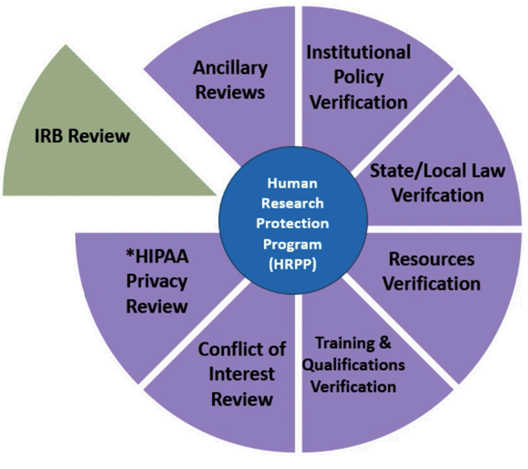

In most cases, the VUMC IRB will still serve as the Privacy Board and will perform a privacy review related to HIPAA Authorization and waivers. Along with the abbreviated application in DISCOVR-e, submission of the IRB approval letter from the IRB of Record is required.

All documents that the Reviewing IRB approved that will be used at VUMC must be provided for VUMC’s HRPP to review for local considerations. Approval letters from the Reviewing IRB that document the approval of each document to be used at VUMC must also be provided for VUMC HRPP review.

This abbreviated application and IRB-approved documentation from the Reviewing IRB must be submitted to and acknowledged by the VUMC HRPP before local study activities occur at VUMC.

Do I need to complete a Request to Cede review REDCap survey like I do when requesting VUMC to the be the Single IRB?
This process is not required when requesting to rely on another IRB. Once the External IRB has approved the overall study, the VUMC study team will submit a “Request Review by Another IRB” application in DISCOVR-e. Attach to this application:
- The IRB approved documents that will be used at VUMC;
- Approval letters documenting that those documents were approved by the Reviewing IRB; and
- Reliance documents and local context forms provided by the External IRB.

This “Request Review by Another IRB” application is not another IRB review. It is a local review with a subsequent acknowledgment letter from VUMC HRPP which verifies that all local requirements are met. This acknowledgment letter must be retained in the research file and provided to the IRB of Record.

Flowchart for VUMC as a Relying Site Submitting to VUMC HRPP

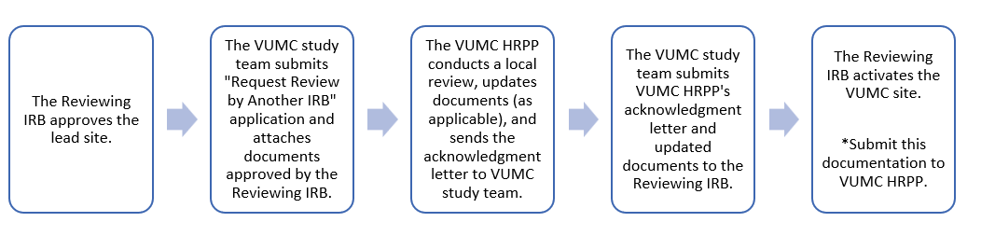

When we rely on an external IRB, can I use the VUMC consent template, or do I have to use the template provided by the Reviewing IRB?
The Reviewing IRB will provide a template informed consent form that has been reviewed and approved by the Reviewing IRB with certain sections allowed to be edited and/or completed with local information. This is the consent version that should be provided to the VUMC HRPP to review. VUMC HRPP will work with the VUMC study team to add applicable local language. The version that VUMC HRPP acknowledges should be provided back to the Reviewing IRB for final approval. That approved consent document is what will be used to enroll participants at VUMC.

The VUMC investigator should not use a consent document unless it has been reviewed and acknowledged by the VUMC HRPP and subsequently returned to the Reviewing IRB for final approval.

What “local” language should I include in the template ICD?
The VUMC HRPP requires that consent forms include VUMC institutionally approved template language for local subject injury, cost language, payment, medical record information and any additional language required by state law relevant to the study. The VUMC HRPP requires use of the standalone HIPAA Authorization form when ceding review. A consent form template language document is located on the VHRPP website under “Single IRB Help” which provides VUMC required language.

I received my local “acknowledgment” letter from the VUMC HRPP. Does this mean the study is “approved” and what should I do next?
As the Relying IRB, VUMC HRPP acknowledges that our local context review is complete. After the VUMC study team receives the acknowledgment FAL in DISCOVR-e, they must forward this acknowledgement letter and VUMC-edited study documents to the Reviewing IRB for IRB-approval.

Both the VUMC HRPP acknowledgment and the IRB of Record’s site activation must occur prior to initiating any research activities.

Flowchart for VUMC as a Relying Site submitting to VUMC HRPP
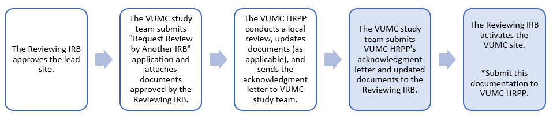

I received a letter from the IRB of Record stating VUMC has been approved/activated as a site, should I submit this to the VUMC?
Yes. Once the IRB of record has approved Vanderbilt as a site, submit an amendment via DISCOVR-e to provide the site activation approval letter. If the External IRB issues stamped consent forms with approval and expiration dates, please submit these copies.

Does the VUMC HRPP stamp documents from the external IRB?
Documents approved by the External IRB (including consent forms) are not stamped by the VUMC HRPP because VUMC is not the Reviewing IRB. However, the VUMC HRPP will stamp the ceded application created in DISCOVR-e. This, along with the documents approved by the IRB of Record, will be uploaded in DISCOVR-e under “Currently Approved Documents” for the study.

Do we use the stamped documents approved by the External IRB or the VUMC IRB acknowledged documents without a stamp?
All documents used by the VUMC study team should be acknowledged by the VUMC HRPP prior to use. Once the VUMC study team provides the VUMC HRPP-acknowledged documents to the Reviewing IRB, the VUMC study team must use the documents in the form that the Reviewing IRB provides them.

For example, if the External IRB provides stamped ICDs, these should be used. Not all External IRBs provide stamped ICDs. Of note: The VUMC IRB still serves as the Privacy Board for most ceded submissions requiring HIPAA determinations. As such, the HIPAA Authorization form should not be stamped by the External IRB. While the VUMC IRB does not stamp the HIPAA Authorization form, the acknowledgment FAL will document the VUMC IRB review and approval of the standalone HIPAA form.

Are there fees associated with VUMC relying on an External IRB for federally funded sponsored protocols?
The VUMC HRPP does not charge a fee to rely on another IRB. However, the lead IRB will most likely charge a fee to the grant or lead study team for the review of external sites.

What are the different ways reliance is documented?
The IRB of Record will direct how reliance will be documented. Most institutions use the SMART IRB Agreement either within the SMART Online Reliance System or with a Letter of Acknowledgment (LOA). Other institutions may use IREx or their own online system.

What are local context forms, why are they important, and who fills them out?
Most reliance agreements require institutions to communicate “local context” items or “local considerations” to the Reviewing IRB.
This information is submitted on forms supplied by the Reviewing IRB and may be called Local Considerations/Flexibilities forms, Communication Plan, Implementation Checklist, etc. Local considerations can include institutional requirements for informed consent language (e.g., billing for injury language, cost to participants, or compensation), attesting to the adequacy of research team training, qualifications, and resources available to them to conduct the study, and providing any relevant conflict of interest management plans. Additionally, local considerations may include local requirements for use of assent forms, a surrogate rider, genetic rider language, a standalone HIPAA Authorization form and any ancillary reviews when the process does not align with the IRB of Record’s procedures.

Collaboration between the VUMC study team and VUMC HRPP is required to complete these forms. All local information provided to the Reviewing IRB must first be acknowledged by the VUMC HRPP. VUMC study teams must provide local consideration forms to the VUMC HRPP for review and acknowledgement prior to sending the documentation to the Reviewing IRB.

What do I need to do if the PI changes:
For PI changes, submit an amendment form within DISCOVR-e. The VUMC HRPP review consists of a review of local human subjects training and qualifications and confirming that the new VUMC PI does not have a COI. If the IRB of Record has not approved the PI changes yet, the VUMC HRPP will send a CAL to request for the IRB of Record to approve the PI Change. This approval should then be submitted in response to the CAL. The VUMC HRPP will acknowledge the CAL response upon receipt of the IRB of Record’s approval letter.
If the IRB of Record has already approved the PI change before it is submitted to VUMC HRPP, a CAL will only be necessary if there are local requirements that need to be addressed.

AMENDMENTS

What do I do if I need to amend the study documents?
Amendments or modifications should be submitted to the VUMC HRPP if the PI and/or study coordinator are updated or if the study is modified in such a way that additional institutional approvals or review of local considerations are required (e.g. radiation safety, conflict of interest, consent template language).

Determining whether local considerations are impacted may be difficult to assess and the Single IRB team encourages study teams to reach out with questions about whether a proposed change should be submitted immediately or at the time of continuing review.

All amendments should be submitted directly to the Reviewing IRB per their local policy.

REPORTNG INCIDENTS

If a VUMC site needs to report a potential unanticipated problem, who do they report to?
Any adverse event or non-compliance with the protocol that takes place at VUMC should be reported to the Reviewing IRB as well as the VUMC HRPP, including breach of confidentiality or data breach, to ensure that appropriate human subjects protections are in place, and to aid in compliance monitoring for the study and investigator. Adverse events and non-compliance with the protocol should be reported to the IRB of Record first except for a data or privacy breach.

Please see HRPP Policy III.L: Reporting Adverse Events, Serious Adverse Events, and Unanticipated Problems Involving Risk to Participants or Others.

Incident Reporting Flowchart for Ceded Studies:

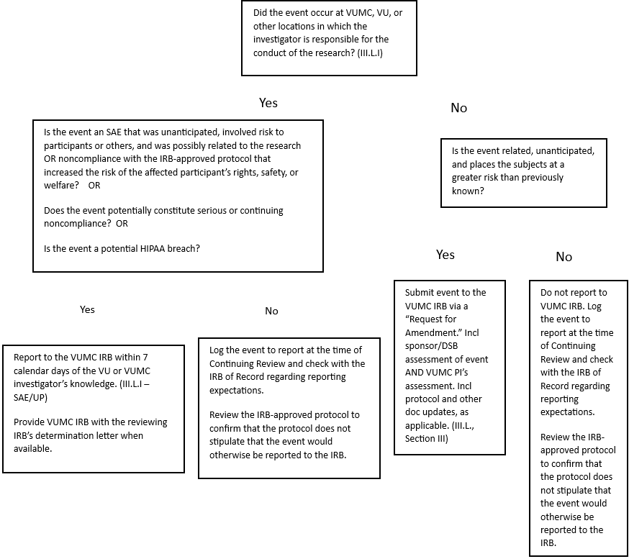
CONTINUING REVIEW

Am I required to submit a continuing review application to the VUMC HRPP?
Yes, if the Reviewing IRB has determined that continuing review is required, a continuing review must also be submitted to the VUMC HRPP.

After the VUMC study team receives the re-approved study documents from the lead site’s continuing review submission form, the VUMC study team will submit a continuing review application in DISCOVR-e. Attach to this continuing review form the continuing review approval letter from the IRB of Record, and any additional supporting materials related to enrollment at VUMC. If the External IRB issues updated consent forms to reflect a new approval and expiration date, and VUMC is an enrolling site that uses the consent forms, please submit these copies.

VUMC HRPP staff will update the expiration date for the local submission in DISCOVR-e based on the External IRB’s approval letter (one month after the External IRB’s expiration date) to ensure that the local continuing review follows the Reviewing IRB’s continuing review.

What if the External IRB does not require a continuing review? Do I need to submit anything to the VUMC HRPP?
If the reviewing IRB has determined that a continuing review is not required for a minimal risk, non-FDA regulated study, the VUMC HRPP requires a study update for reporting of enrollment numbers to document participant accrual for research studies. You will receive a study update email reminder to provide enrollment totals on the investigator dashboard in DISCOVR-e.

When am I able to close the study, do I submit a form to VUMC HRPP and the Reviewing IRB?
Institutions may have varying policies documenting when studies can be closed or inactivated. Defer to the Reviewing IRB’s policy on study closures to determine when the VUMC site can be closed (e.g., during data analysis if all data is de-identified vs. when all data queries are complete). The VUMC HRPP may verify the status of the data and other details upon request for study closure.

- If the study requires continuing review: VUMC investigators will follow the Reviewing IRB’s procedures for closing studies first. After the VUMC site is closed with the Reviewing IRB, the VUMC study team must submit a continuing review form to close the site locally. Attach the Reviewing IRB’s closure letter to the submission.

- If the study does not require continuing review:
Even though continuing review forms were not required throughout the study, the VUMC study team will use a continuing review form to report study closure to the VUMC HRPP.

VUMC investigators will follow the Reviewing IRB’s procedure for closing studies first. Once the Reviewing IRB has approved the site closure, submit a continuing review form to the VUMC HRPP and indicate that the study is closed. Attach to the submission form documentation of the study closure from the Reviewing IRB.

