Vanderbilt University Medical Center Biomedical Research Environment
Vanderbilt University Medical Center (VUMC) is an academic medical center with a thriving research enterprise recognized for the advancement of biomedical discoveries and application of new knowledge to improve human health. VUMC and Vanderbilt University legally separated in 2016 yet continue to share a unified academic mission through the Vanderbilt University School of Medicine (VU-SOM). VU-SOM’s “one Vanderbilt” philosophy promotes a strongly trans-disciplinary, collaborative culture that spans the continuum of basic, translational, clinical, and population-based research. Numerous NIH, DARPA, and other grants fund research and shared core facilities covering a broad range of disciplines, including infectious diseases, immunology, cancer, diabetes, digestive disease, and neuroscience. VUMC maintains an active support infrastructure for grant-funded projects totaling $937M in research awards (2024), including $532M in NIH grants and contracts as part of VU-SOM (ranked 5th in NIH funding). This trans-institutional research enterprise is renowned for high impact discoveries, with an outstanding training environment as reflected in VU-SOM’s 41 active NIH training grants.

VUMC is strongly committed to developing and sustaining shared research resources, which are available for innovation and collaboration across Vanderbilt to enable rapid, scalable translation between basic science and clinical research. VUMC has invested over $160M in shared research resources since 2001, and continues to invest up to $5M annually to offer investigators advanced technologies and research services. Of note, the Animal Care and Use Program and facilities are maintained and operated by VUMC for all animal research efforts at Vanderbilt. VUMC also provides IRB oversight to support all human subjects research at Vanderbilt, through the VUMC Human Research Protection Program.

VUMC Shared Resources and Core Facilities
VUMC’s shared research resources and core facilities (collectively, “cores”) advance biomedical discovery by offering the latest research capabilities and promoting scientific exchange and collaboration. VUMC maintains an institutional philosophy that ensures strong support for cores. VUMC has invested more than $160M in cores since 2001 and continues to invest up to $5M each year to maintain and create shared resources. In turn, cores directly advance VUMC’s Strategic Directions and promote a collaborative research culture. Collaborations with cores benefit VUMC researchers, as well as investigators in local biomedical research institutions (e.g. Vanderbilt University (VU), the Veterans Administration and Meharry Medical College) who utilize VUMC core services. As partners with VU in an integrated learning environment, cores also help ensure that Vanderbilt remains a national leader in biomedical education and training.
VUMC instituted principles of centralized organizational support for cores more than 20 years ago. Specialized-technology core facilities were formally organized to centralize administration, improve quality control, produce economies of scale, and provide access to services and technologies difficult (or impossible) for individual investigators to acquire. This framework continues to facilitate both the successful financial administration and necessary scientific oversight of shared resources. Today, there are more than 80 cores across VU and VUMC, including 50 housed at VUMC. As a guiding principle, all VU and VUMC faculty, trainees, and staff have equitable access to the entire network of shared resources.
The Office of Research works closely with VUMC cores and provides operational oversight and guidance. This helps ensure that financial needs are efficiently identified and prevents any lapse in core operations. In addition, VUMC provides dedicated administrative support, access to a sophisticated web-based invoicing system, and compliance oversight. Cores necessarily encompass a broad range of services, technology, and expertise, but VUMC’s centralized approach prevents needless duplication of research resources. Overall, centralized administration of the core network enables effective use of federal and institutional dollars while supporting the broadest possible spectrum of biomedical research.
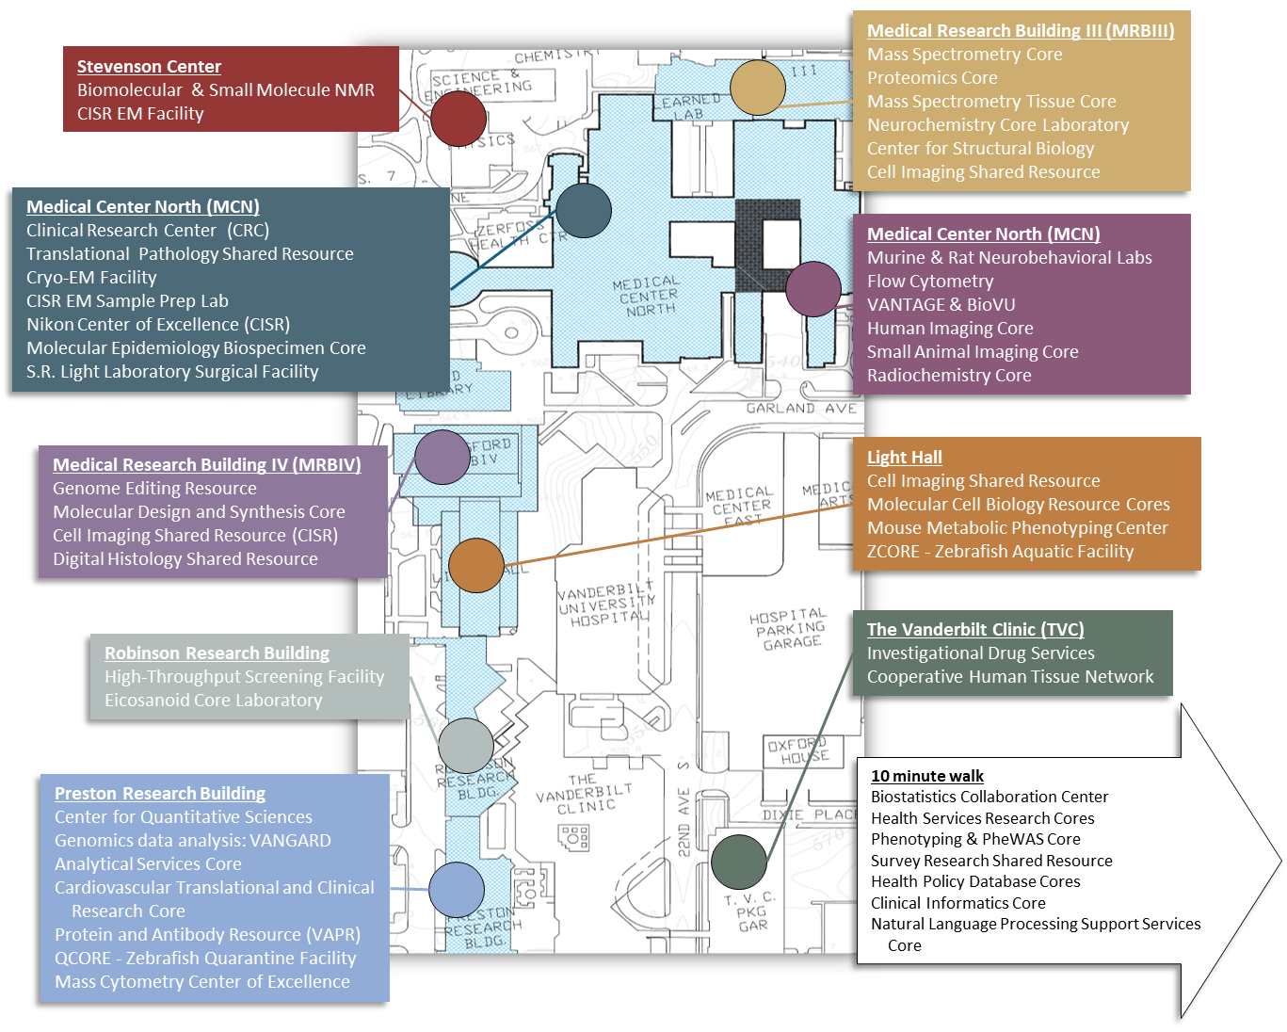

Administrative and Scientific Oversight of Cores
Most VUMC cores are based in a research center or department, yet serve broader institutional strategic goals and expansive user bases. VUMC cores are thus operated under a shared management strategy with robust leadership from multiple scientific experts (Fig. 1). Centralized financial and administrative support frees the core’s scientific leaders to develop new technology, acquire highly specialized instrumentation, and train technical personnel. Each core is overseen by a tenured faculty director whose research is interwoven with the core’s activities. This scientific connection ensures that core services remain at the cutting edge. The core’s full-time operations manager typically holds an advanced degree in science and manages the facility’s day-to-day functions, technology development, and staff training.

The VUMC Office of Research (OOR) provides dedicated business support services, financial planning, policy guidance, and scientific oversight coordination for all shared resources, working closely with department and center leadership to ensure the financial and scientific success of the core. This shared oversight model — science working with administration — enables each core to operate at peak effectiveness. Each level of oversight is further detailed below.
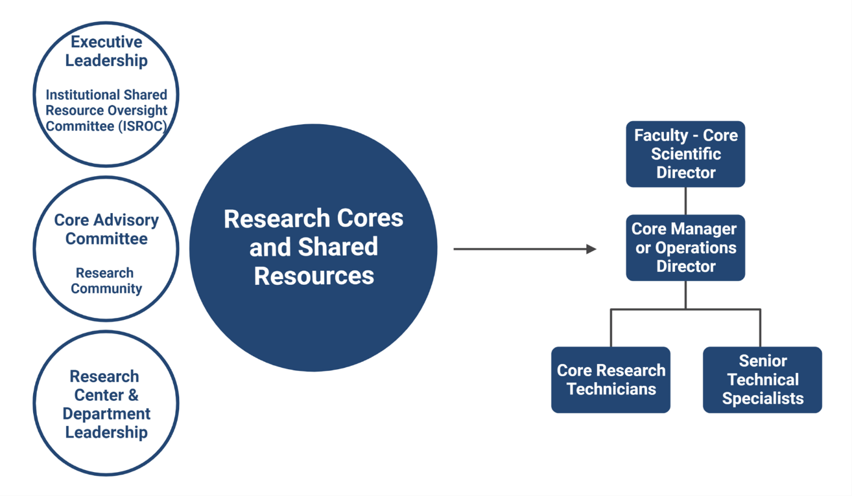
Figure 1. The VUMC Model: An integrated approach to the administration and oversight of shared resources.

Executive Leadership of Cores
VUMC’s Chief Scientific and Strategy Officer (CSSO) and OOR provide executive oversight of core facilities, working closely with core home centers and departments, the Institutional Shared Resource Oversight Committee (ISROC) process and individual core advisory committees. OOR functions as a key liaison between the CSSO, ISROC, and core directors/managers. OOR also directly monitors core facilities to ensure compliance with the VUMC’s administrative, financial, and scientific policies. OOR staff routinely work with core managers and administrators to develop and revise business plans upon changes in service focus, staffing, or core usage. In addition to one-on-one interactions with core leaders, the OOR hosts quarterly meetings for both core managers and administrators, providing training, policy updates, and a forum for sharing feedback and best practices.

The VUMC CSSO and OOR also serve as primary contacts for Vanderbilt University (VU) research leaders, who share a strong interest in supporting Vanderbilt’s research resources and cores. VUMC collaborates closely with the VU Vice Provost for Research Dr. Padma Raghavan, the VU Dean of Basic Sciences Dr. John Kuriyan, and other partners.

Institutional Shared Resource Oversight Committee (ISROC)
VUMC first established an Institutional Shared Resource Oversight Committee (ISROC) in 2010 to advance both development and awareness of cores as integral to Vanderbilt’s translational science and discovery efforts. The ISROC now functions as a nimble framework designed to ensure that core users benefit from consistent and equitable access to scientific technology and expertise, often via ad hoc advisory panels of faculty experts and institutional leaders chaired by Chief Scientific and Strategy Officer Dr. Jennifer Pietenpol. The ISROC provides guidance as needed on specific issues related to core operations; enabling infrastructure; and support for research resources. Reflecting VUMC’s collaborative culture, the ISROC leverages existing leadership and reporting structures, including each core’s scientific advisory committee, to gather and relay feedback from users and the broader research community.

Scientific Advisory Committees
Each core is encouraged to establish faculty advisory committee of scientific experts. With guidance from the OOR, the core director identifies members with broad representation from research center leadership, major users, and technology experts, balanced for cross-departmental/center usership. Susan Meyn, Associate Vice President for Research Resources and OOR Senior Director, is an ex officio member of each advisory committee. Core advisory committees report findings and recommendations to the OOR, which may result in further review via ad hoc ISROC process. Advisory committees are regularly engaged in-person or virtually to ensure that faculty and research leadership have a voice in the development of new services, and that cores are responsive to investigator needs. The advisory meetings primarily focus on core science, services and research utility, but also include a review of finances (e.g. business planning and fee structures) and quality management (e.g. best practices for rigor and reproducibility). The committee may also serve as the S10 instrument advisory committee to meet NIH oversight and reporting requirements at the discretion of the S10 grant Principal Investigator.

S10 shared instrumentation grant review and coordination
The Office of Research (OOR) provides centralized program management for NIH S10 Shared Instrumentation Grant applications and awards. OOR coordinates review of internal proposals for S10s and other shared equipment grant programs. OOR works with the Chief Scientific and Strategy Officer and the Institutional Shared Resource Oversight Committee (ISROC) to ensure that each application submitted to NIH is scientifically distinct and effectively leverages existing institutional support. Furthermore, OOR reviews proposed applications and makes recommendations to the CSSO and ISROC for institutional commitments including matching funds, space, and/or renovations. Highest priority is given to internal proposals submitted in collaboration with one or more core facilities. Because VUMC cores are institutionally-supported and operate under strong management, equipment support, and user access plans, placing new equipment into a core is typically a turnkey proposition that results in rapid investigator access to new technology.

OOR provides application development support by maintaining grant-ready text appropriate to the NIH S10 program and facilitating coordination of especially complex applications. OOR also works closely with institutional leaders to develop strong letters of support detailing the funding, space, and other resources dedicated to each application. Additionally, OOR provides the S10 instrument performance table which is required to accompany each new application. Preparing the table involves working closely with the Principal Investigators of all existing S10 equipment across VUMC. By centralizing this reporting, OOR frees individual applicants to focus on preparing their applications.

OOR provides additional administrative support for Principal Investigators after an S10 grant is awarded. Over the past 10 years, VUMC has received over $20M in S10 awards and provided more than $7.6M in institutional matching funds. OOR manages the matching fund support, which supports instrument purchases and operation to help keep user fees low. Additionally, OOR coordinates institutional-level core oversight and prepares annual NIH-required reports of instrument performance, including instrument status, usage, and impact metrics. The OOR encourages all Vanderbilt researchers to specifically acknowledge the appropriate S10 grant award(s) when publishing data produced using S10 grant-funded equipment. OOR maintains a website listing current S10 instrument awards and sample citations for ease of use by authors. As an incentive to cite S10 grants, OOR offers funding vouchers redeemable in VUMC core facilities to all investigators who submit publication citations: one voucher for each verified citation. This additional incentive to properly acknowledge S10 grants helps maximize the impact and transparency of NIH support.

VUMC Philosophy on Core Service Fees and Chargebacks
VUMC strives for a core management philosophy that supports high‐quality scientific investigation, alignment with VUMC’s programmatic vision, and strategic investment in new technologies and shared resources. While each core offers unique expertise, services and/or products, a unified approach to financial, administrative, and scientific accountability is facilitated by the Office of Research (OOR). Most cores are supported by user fees that are “charged back” to investigators’ grants. By definition, VUMC cores and shared resources are not dedicated to a single research group or department, but should maintain equitable access to all investigators and be open for new business. Assessment of priority access requires actively involved scientific and managing directors who interact with researchers and core staff, ensuring that overall access is not limited and service fees are charged appropriately and consistently. User training and education are considered an integral part of core service. As with all core services, training costs are charged back to investigators as appropriate. All VUMC core service fees are reviewed and approved by OOR and must be reasonable when compared with other institutions or commercial companies offering similar services. Equally important, user fees must be documented and published so that users can confidently compare costs when choosing to use core services. These principles for shared operational management of core facilities are laid out in detail in comprehensive operational guidelines for VUMC research shared resources and core facilities.

Centralized Usage and Invoicing System
VUMC maintains a shared financial management philosophy for cores and shared resources. The institution invests substantial resources to facilitate internal and external billing activity, manage and track core usage, and ensure compliance with relevant VUMC and federal policies. In 2013, VUMC transferred core management from the home-built CORES platform to iLab Solutions (Agilent CrossLab), which is now used for all core financial administration. In fiscal year 2024, VUMC’s comprehensive management system efficiently processed more than $73M in core charges.
A centralized management system that tracks operational efficiency enables each resource to better achieve “break-even” operations within the three-year startup phase. The institutional goal is to balance the combined support from NIH center grants and charged-back user fees with annual core operational expenses. The system allows each core to charge services performed to any Vanderbilt investigator’s account, ensuring a regular and timely collection of revenue, and it is fully integrated with Vanderbilt Institution for Clinical and Translational Research (VICTR) funding and voucher award system. Investigators apply for VICTR vouchers to fund specific core services for their research project. They can then use VICTR vouchers to easily pay service charges in real time. The centralized system also allows researchers to place orders and reserve instrument time, monitor core usage over time, and allocate charges among multiple payment types. Invoices are generated and sent monthly to both Principal Investigators and administrators for review and approval.

Internal Grant Program for Core Facilities
VUMC supports ongoing development of new technology so that cores can respond to the research community’s evolving needs. VUMC periodically allocates funds to support institutional cores with new technology or protocol development. For example, internal competitions solicit core proposals for capital equipment, renovations, or small pilot projects that enhance core offerings. Primary review criteria for these proposals include benefit to users, scientific impact, and reasonable scope/feasibility. Proposals are ranked by an institutional review committee with final funding decisions made by the Chief Scientific and Strategy Officer. Since 2010, VUMC has made 46 awards to 20 different cores, totaling more than $1.5M.

Rigor, Reproducibility and Transparency
VUMC research cores and shared resources have an institutional role in supporting researchers in the responsible conduct of research through training, informal mentorship, and core services. Cores are particularly well-positioned to facilitate good experimental design and validated methods; provide authentication services for key biological and/or chemical resources; and define and establish rigorous methods for acquiring and analyzing large, complex experimental data sets. A working group of Vanderbilt core personnel developed guidance for cores to enhance their role in promoting intellectual rigor and appropriate transparency to encourage and enable reproducibility in research. Through the implementation and sharing of these best practices, cores demonstrate to users the effectiveness of a more rigorous approach to science, enabling individual investigators to better incorporate these practices into their own research programs.

Data Retention and Management
Cores play a key role in generating research data and metadata. While principal investigators have ultimate responsibility for data management and retention, cores should maintain transparent data management policies and practices that researchers can easily access and understand. The VUMC Office of Research has developed formal guidance and a data policy template to help each core establish a data management policy custom to their services and technologies. Each core’s data management policy outlines key practices such as data storage and transfer, data retention periods, and planned data destruction practices. Any requested exceptions to the policy must be acknowledged in writing by both the core manager and the principal investigator. By maintaining consistent and transparent data policies, VUMC cores encourage thoughtful data stewardship by sponsored research programs and support investigator compliance with internal and federal data retention and sharing policies.

