**Effectiveness of Antipsychotic Drugs in Patients with Chronic Schizophrenia**

Jeffrey A. Lieberman, M.D., T. Scott Stroup, M.D., M.P.H., Joseph P. McEvoy, M.D., Marvin S. Swartz, M.D.,

Robert A. Rosenheck, M.D., Diana O. Perkins, M.D., M.P.H., Richard S.E. Keefe, Ph.D.,

Sonia M. Davis, Dr.P.H., Clarence E. Davis, Ph.D., Barry D. Lebowitz, Ph.D., Joanne Severe, M.S.,

and John K. Hsiao, M.D., for the Clinical Antipsychotic Trials of Intervention Effectiveness (CATIE) Investigators*

**What is CATIE?**  
A **double-blind, active-control clinical trial** sponsored by the National Institute of Mental Health (NIMH) that was designed to **compare the effectiveness of atypical and conventional antipsychotic drugs.** The **primary outcome measure was the discontinuation of treatment for any cause.**  
  
**Which drugs were tested in CATIE?**

Perphenazine  
Olanzapine  
Quetiapine  
Risperidone  
Ziprasidone

**Study Design:**

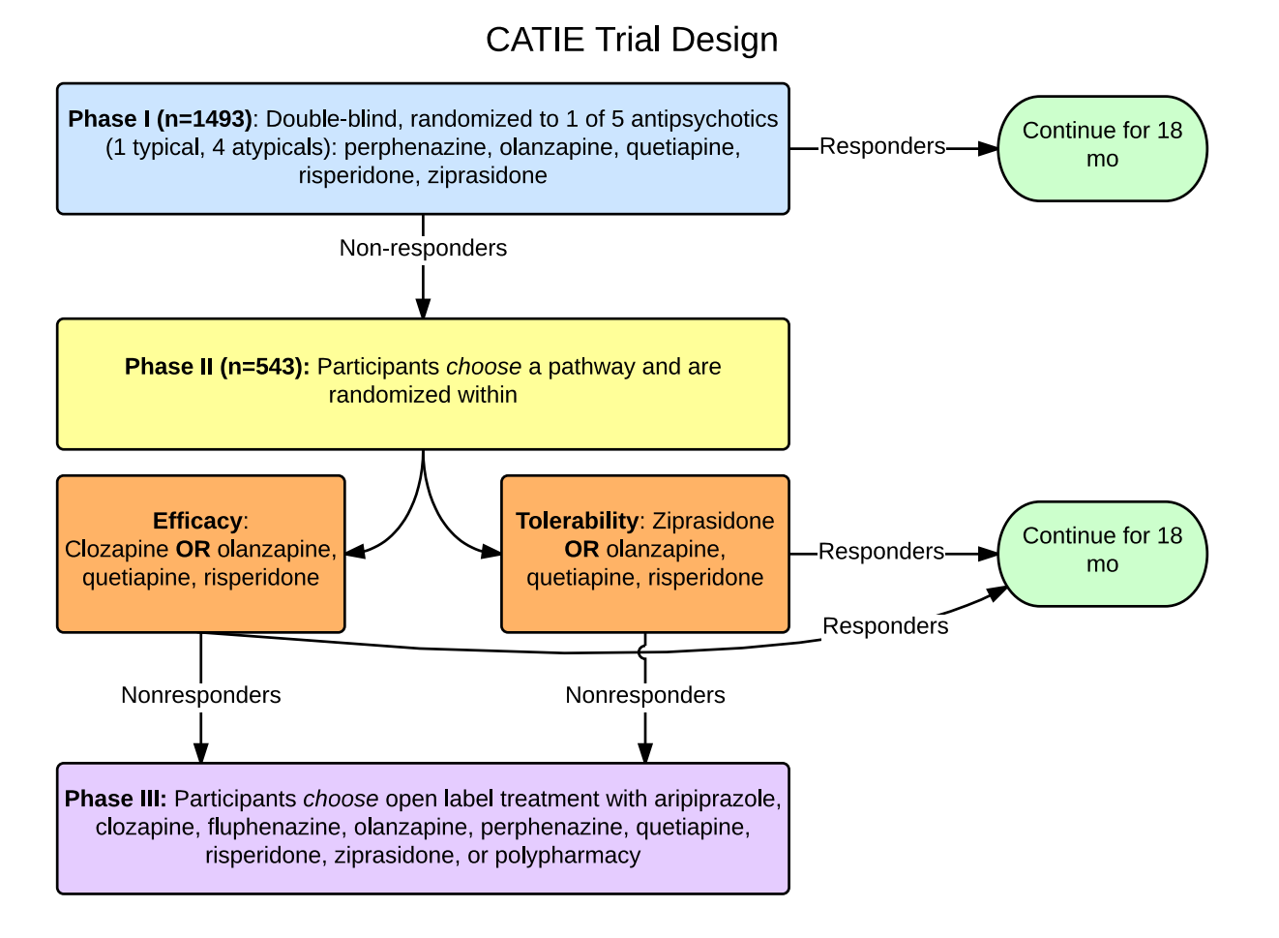  
**What kinds of patients were included?**  
CATIE patients were between 18-65 years old, diagnosed with schizophrenia based upon the DSM-IV, and able to take oral medication.  Patients were included **even with coexisting conditions** and/or if taking other medications.  
  
**Who was excluded?**

* Schizoaffective Disorder
* Mental Retardation
* Cognitive Disorders
* Hx of adverse reactions
* History of treatment resistance
* Only one previous psychotic episode
* Pregnant
* Breastfeeding
* Serious medical condition

**What were the results?**  
1. Overall, **74 percent of patients discontinued the study medication before 18 months** (1061 of the 1432 patients who received at least one dose).  
2. The **time to the discontinuation of treatment for any cause was significantly longer in the olanzapine group than in the quetiapine (P<0.001) or risperidone (P=0.002) group, but not in the perphenazine (P=0.021) or ziprasidone (P=0.028) group.**3. The **times to discontinuation because of intolerable side effects were similar among the groups**, but the rates differed (P=0.04); olanzapine was associated with more discontinuation for weight gain or metabolic effects, and perphenazine was associated with more discontinuation for extrapyramidal effects.



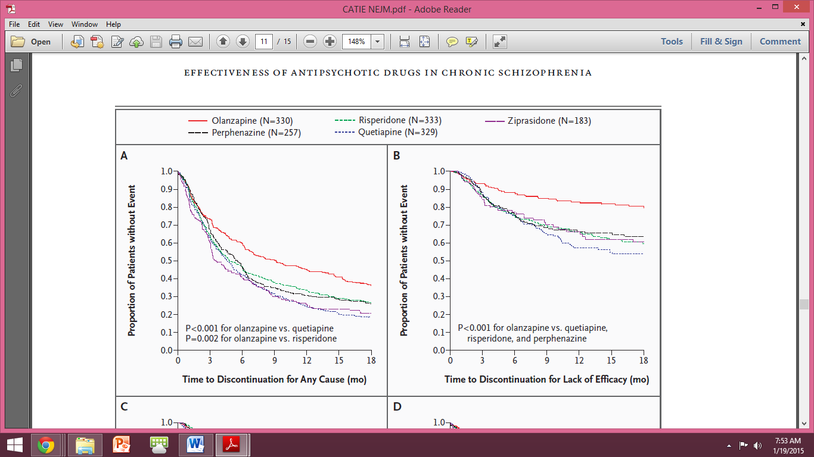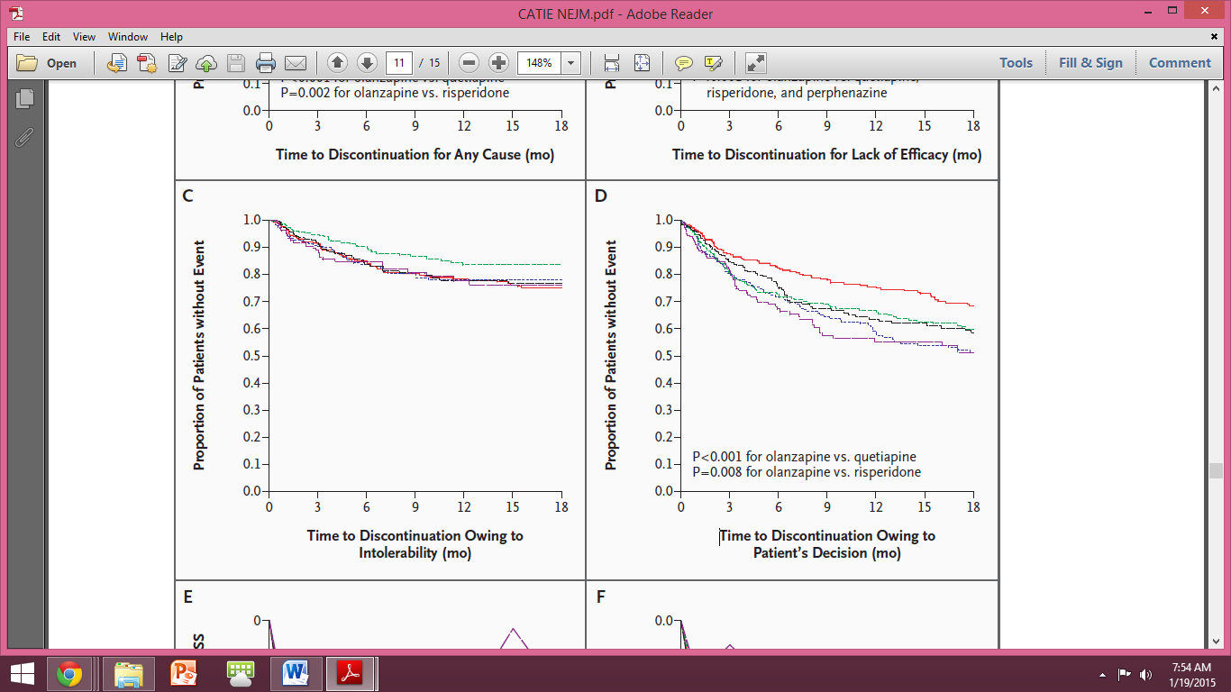

**Conclusion**  
In summary, patients with chronic schizophrenia in this study discontinued their antipsychotic study medications at a high rate, indicating substantial limitations in the effectiveness of the drugs. **Within this limited range of effectiveness, olanzapine appeared to be more effective than the other drugs studied, and there were no significant differences in effectiveness between the conventional drug perphenazine and the other second-generation drugs.** There were **no significant differences among the drugs in the time until discontinuation of treatment owing to intolerable side effects.** However, olanzapine was associated with greater weight gain and increases in glycosylated hemoglobin, cholesterol, and triglycerides, changes that may have serious implications with respect to medical comorbidity such as the development of the metabolic syndrome.