The Sequenced Treatment Alternatives to Relieve Depression (STAR\*D) Trial

37 month period with 4041 outpatient participants ages 18-75 at 41 clinical sites across the U.S.

Participants were followed from 12-14 weeks and 1 year follow up for participants with remission

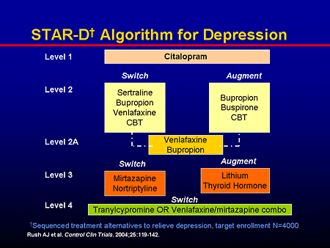 Medscape.com

LEVEL 1: Citalopram – SSRI

* 2876 participants
* Remission rates of 28-33%
* Mean remission time was 6.7 weeks
* Response rate of 47%, mean time was 5.7 weeks
* Characteristics related to remission
  + White, female, married, more educated, higher income, private insurance, current employment
* Disadvantages
  + Concurrent general medical and psychiatric disorders, longer current episodes, poorer function and quality of life

LEVEL 2: Switch or Augment - random or accepted by participants

* 1439 participants were intolerant to citalopram or received inadequate benefit and proceeded to this level
* Designed to compare medications with different pharmacologic effects (sertraline, a second SSRl; bupropion-SR, a nonserotonin active agent (weak norepinephrine and dopamine reuptake inhibitor); venlafaxine-XR, a reuptake blocker of both norepinephrine and serotonin
  + Switch: remission rates for these medications were not different
  + Aument: with buproprion or venlafaxine (although the above algorithm includes buspirone, this medication was not commented on in the referenced publication listed at the bottom of this document).
    - about 1/3 of participants in remission
    - mean remission time 5.4-6.2 weeks
    - no difference in remission rates but bupropion was favored - less drop out, less SE, greater baseline symptom reduction
* 147 participants received cognitive therapy switch or augment
  + ¼ of partcipants in remission
  + No significant difference remission or response rates, tolerability, or # of weeks in treatment
* statistical difference in the mean time to remission
  + 55 days for cognitive therapy and 40 days for medication augment.

LEVEL 3:

* 377 participants experienced intolerance or received inadequate benefit
* Switch to mirtazapine (Noradrenergic and specific serotonergic antidepressant)or nortriptyline (TCA)
  + Remission rates of 12.3% and 19.8% or 8% and 12.4%, respectively – no significant difference.
* Augment with lithium or thyroid hormone to either 1) a medication switch from level 2 or2) to citalopram (for those who received a level 2 augment)
  + Remission rates of 15.9% and 24.7% or 13.2% and 24.7%, respectively – no significant difference.
* Lithium had more side effects, Thyroid hormone favored due to better tolerance and lack of necessity in checking blood levels.

Level 4:

* 109 participants
* Tranylcypromine, MAOi or venlafaxine + mirtazapine
* Remission rates of 6.9% and 13.7% or 13.8% and 15.7%, respectively
* dose of tranylcypromine did not reach recommended maximum dosage.
* Participants more likely to leave trial due to side effects and the 2 week washout period
* the combo was more accepted, tolerated, and did not have dietary restrictions.

Overall remission rates and rates of treatment intolerance

* Step 1: 37%, 16%
* Step 2: 31%, 20%
* Step 3: 14%, 26%
* Step 4: 13%, 34%

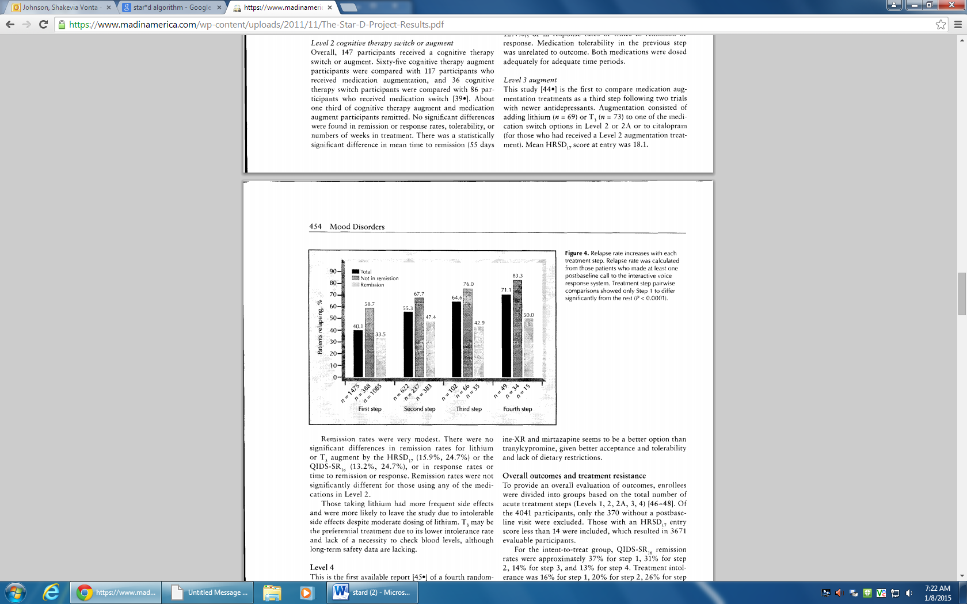

More relapse with more acute treatment steps

Highlight the need to achieve remission with acute treatment (as opposed to response) and the need to aggressively achieve the desired outcome as early as possible.

Reference: The STAR\*D Project Results by Walden D., et al. (2007)