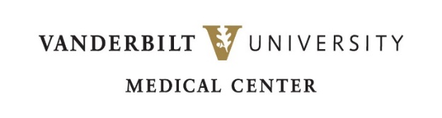

**FACULTY POSITION IN CANCER OR SYSTEMS iMMUNOLOGY**

**Vanderbilt University & Vanderbilt University Medical Center**

**Department of Medicine**

**Vanderbilt Center for Systems Biology**

**Vanderbilt Center for Immunobiology (VCI)**

Vanderbilt University (VU) and Vanderbilt University Medical Center (VUMC) invite applications for tenure-track faculty positions at the Assistant or Associate Professor level (PhD, MD, MD/PhD) in the area of cancer or systems immunology. Candidates of diverse backgrounds with potential research programs in cancer, inflammation, innate immunity, autoimmunity, and computational immunology are encouraged to apply.  Successful candidates will be members of the Vanderbilt Center for Systems Biology and VCI and appointed to the Department of Cell & Developmental Biology or Medicine depending on programmatic fit. These dynamic groups provide an excellent scientific environment with junior faculty mentoring. Many collaborative opportunities will be available through memberships in these groups. Successful candidates will be expected to establish and maintain an independent research program and participate in teaching of graduate and medical students. Candidates should have substantial post-graduate training highlighted by peer-reviewed publications that demonstrate creativity and productivity with a defined research program.

VUMC, located on the Vanderbilt University campus, is home to internationally recognized programs in inflammation, immunology, host-microbe interactions, bioinformatics, drug discovery, global health, imaging science, pharmacology, proteomics, and vaccine science.  The Vanderbilt University School of Medicine consistently ranks in the Top 20 US Medical Schools and provides outstanding opportunities for scholarship, collaboration, and teaching.

The Vanderbilt University campus is located in the heart of Nashville, the capital of Tennessee, known internationally as “Music City, USA”. Nashville is also the home to professional sports teams, the Nashville Symphony, the Frist Center for the Visual Arts, and numerous activities for outdoor enthusiasts.  Nashville is a wonderful place to live, work, and raise a family.

Applicants should send a *curriculum vitae*, a statement of current and future research interests, and provide names for least 3 references. To apply click below:

<http://apply.interfolio.com/156337>

Submission deadline is November 30, 2024